Assignment of ECS microservies with CI/CD Pipeline

Overview :-

In this Documentation :-
We have to make 6 microservices in a single cluster using ECS, it will have 6 pipeline for 6 microservices. And the dockerfile should have application inside it.
All services should run from Terraform only .

Define Terraform :-
Terraform is an IAC tool, used primarily by DevOps teams to automate various infrastructure tasks. The provisioning of cloud resources, for instance, is one of the main use cases of Terraform. It's a cloud-agnostic, open-source provisioning tool written in the Go language and created by HashiCorp.

Define Docker :-
Docker is a software platform that simplifies the process of building, running, managing and distributing applications. It does this by virtualizing the operating system of the computer on which it is installed and running.
Dockerfile:-
A Dockerfile is a text document that contains all the commands a user could call on the command line to assemble an image. This page describes the commands you can use in a Dockerfile .

Step 1 :-
Create 6 dockerfile application is running inside it.

Step 2:-
And all dockerfile push on ECR
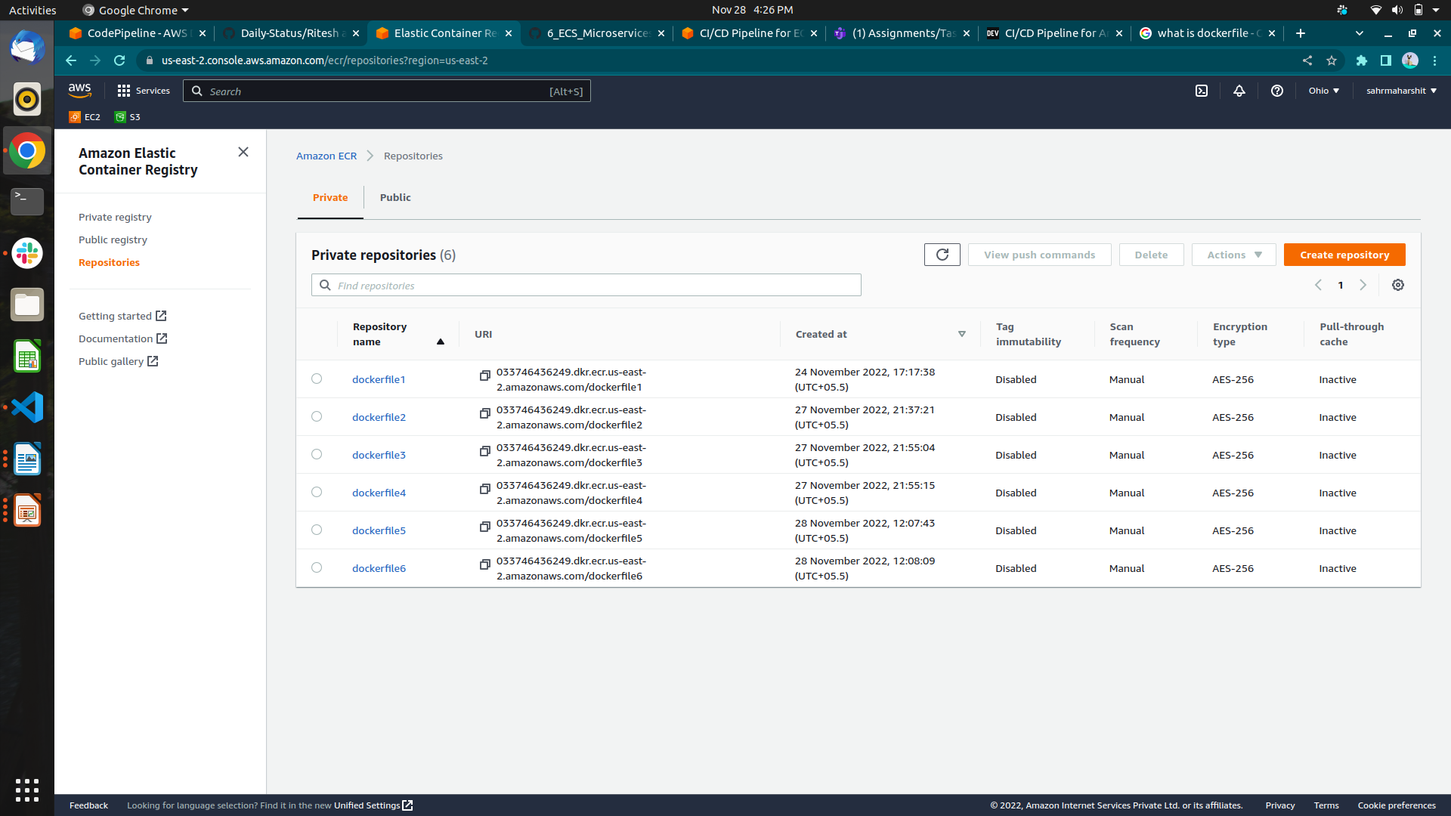
Step 3 :-

The VPC script has VPC , Subnets and Internet Gatway resources .

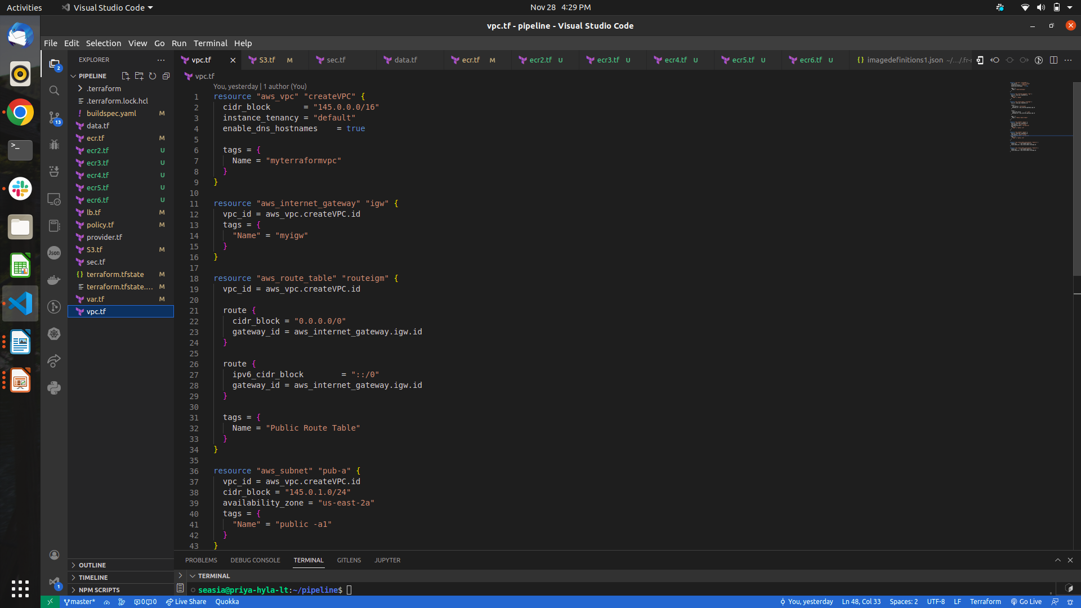
Step 4:-

ECS :-
Amazon Elastic Container Service (Amazon ECS) is a highly scalable and fast container management service. You can use it to run, stop, and manage containers on a cluster. With Amazon ECS, your containers are defined in a task definition that you use to run an individual task or task within a service.

ECR :-
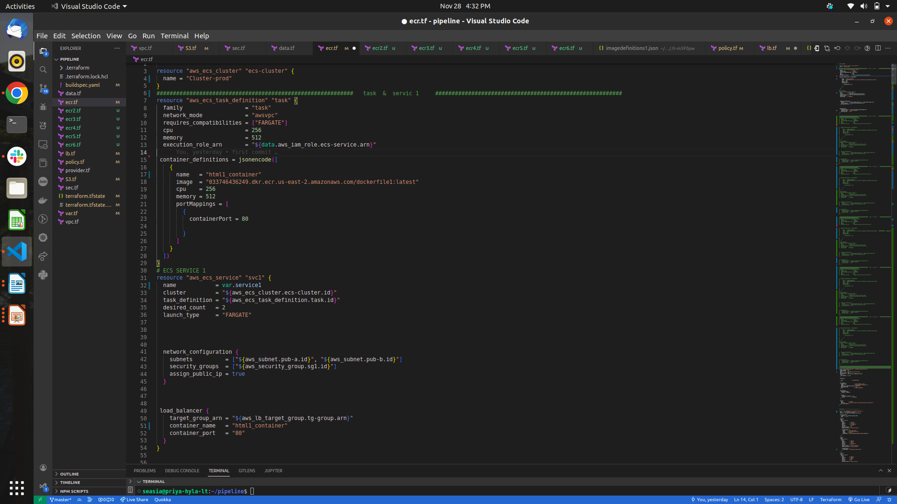
Amazon Elastic Container Registry (Amazon ECR) is an AWS managed container image registry service that is secure, scalable, and reliable. Amazon ECR supports private repositories with resource-based permissions using AWS IAM.

Step 5 :-
Create CI/CD pipeline

CodeBuild Projec
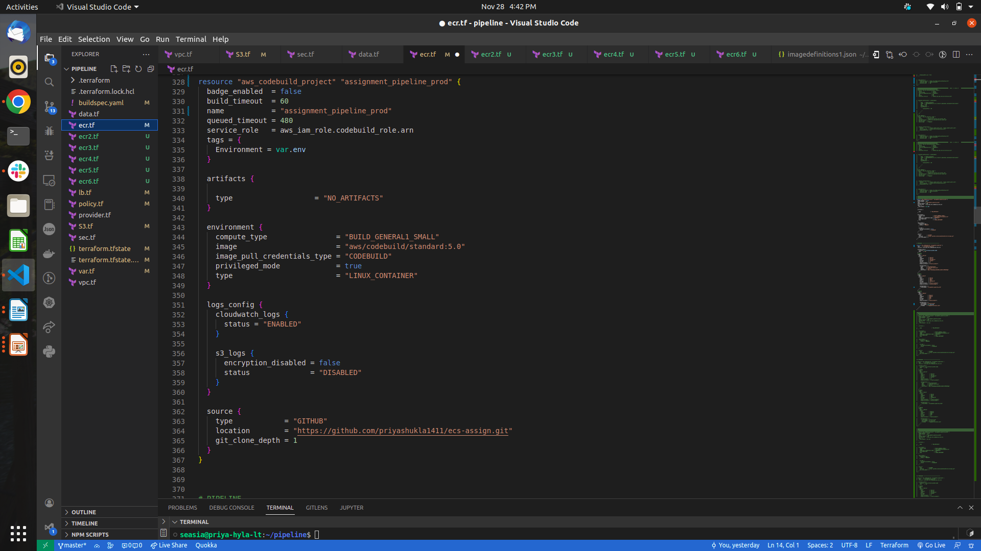

Buildspec.yml
- This file is very important to create the Docker Image and Pull it to ECR repository.
- To update the ECS service is important to specify the containerName and imageUri in a JSON file with the name imagedefinitions.json. This file is an artifact.To update the ECS

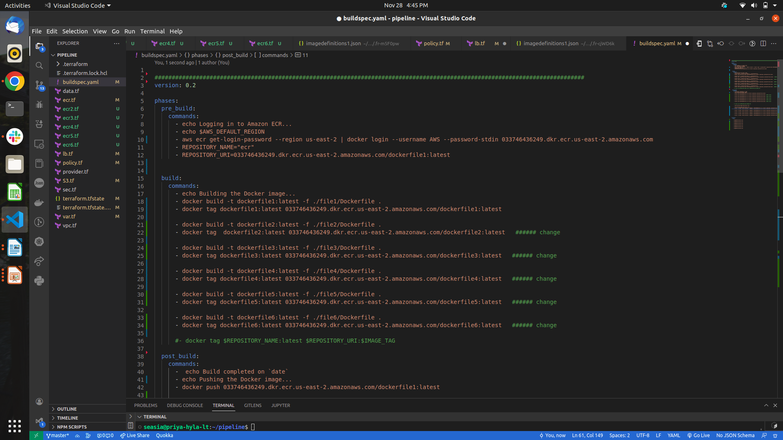

Step 6 :-
Apply 3 Commands ------- 1. terraform init
---------- 2. terraform plan
---------- 3. terraform apply
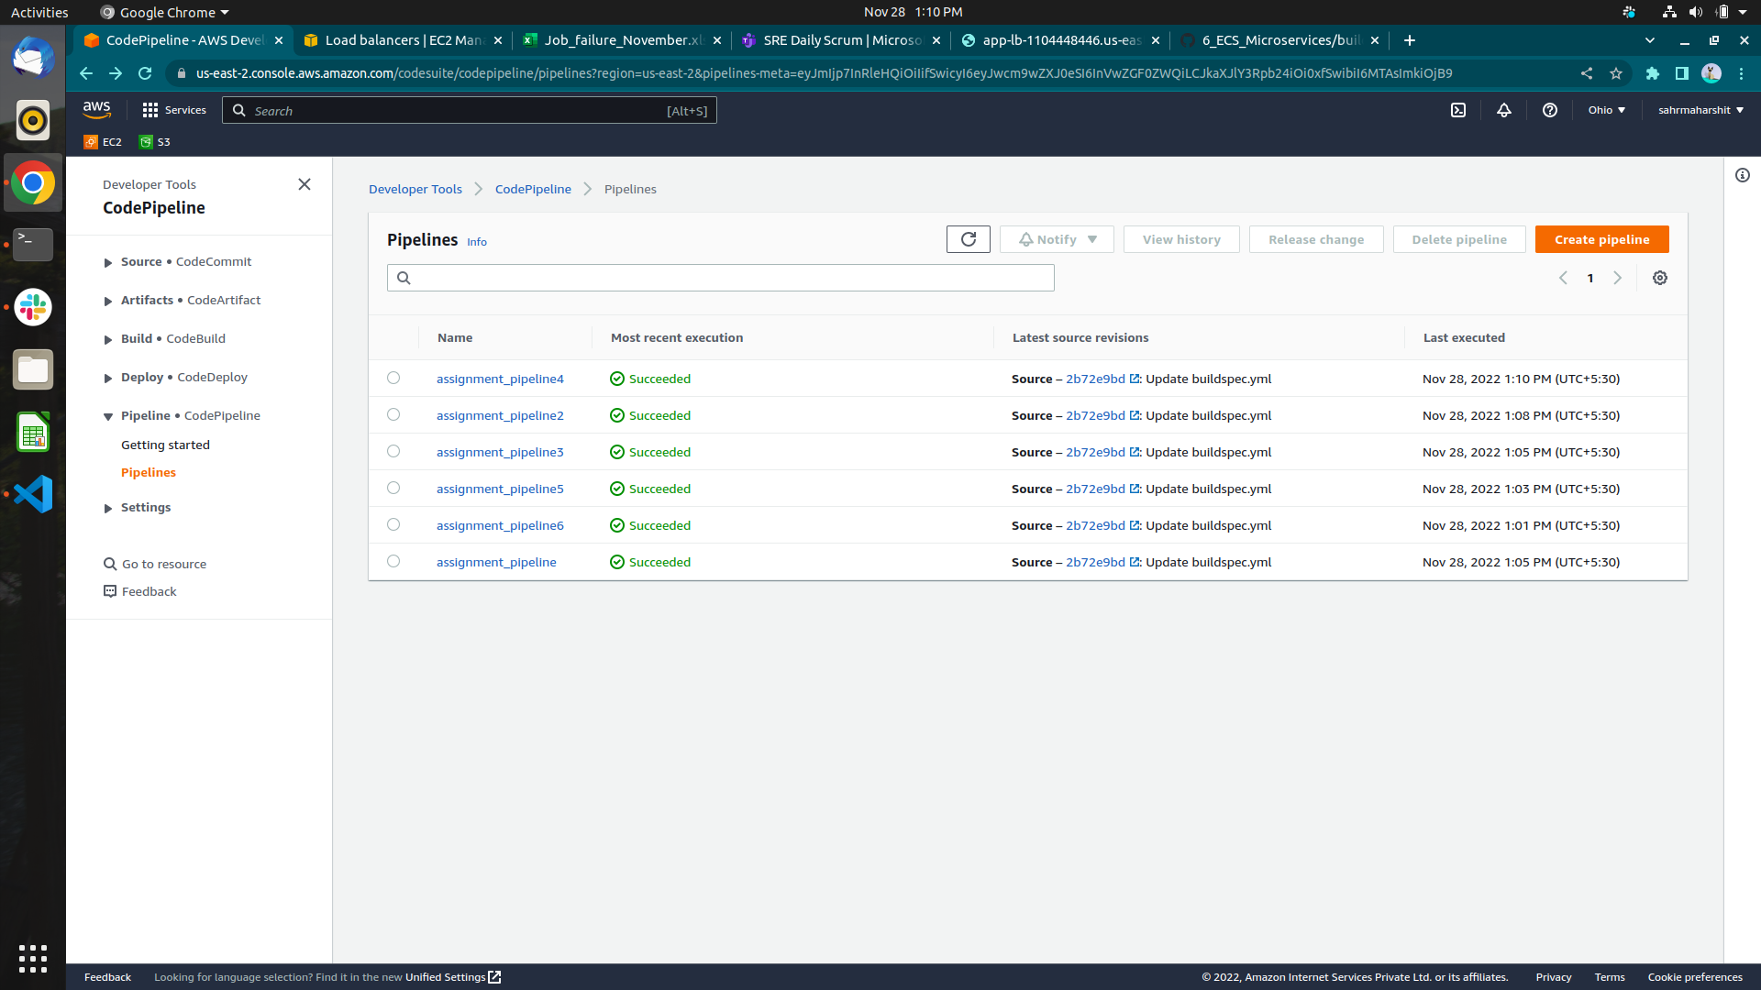
code has been successfully created
And 6 pipelines are successfully created .

